Welcome To
1572 Moorings drive #11a
Reston, va 20190

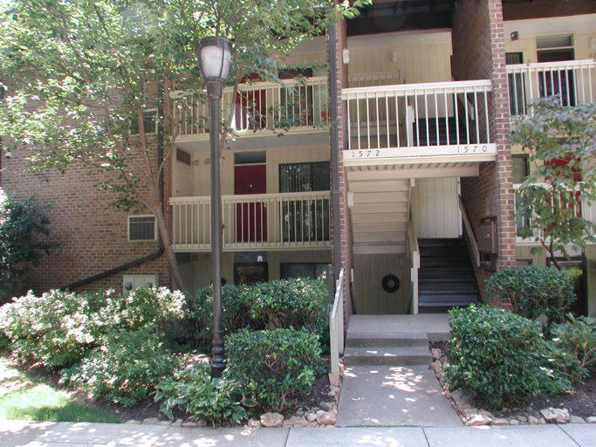
Home Sqft. | 963
Bedrooms | 1
Bathrooms | 1.5
Living Room
Dining Room
Kitchen
Master Bedroom
Foyer

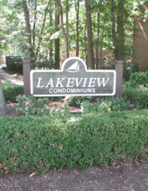

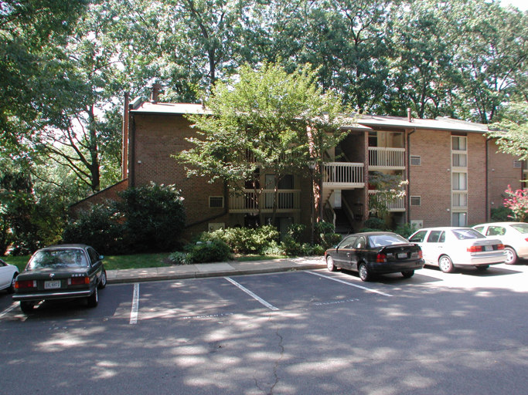

Presented By:


John Thompson

Samson Realty, LLC

14526 Lee Road, Suite 100
Chantilly, VA 20151

Cell: 703.606.0475 Fax: 703.896.5037
E-mail: John@SamsonRealtor.com
Virtual Tour: www.samsonrealtor.com

Noteworthy Features

Lakeview Condominums are located adjacent to beautiful Lake Anne and just a short walk from Lake Anne Plaza shopping, dining and personal services. The Plaza on the water is truly one of the most unique settings in Northern Virginia and a benchmark of both residential & commercial architecture and design. Lake Anne is the showcase of the first “new town” developed in the United States post World War II. Built in the 1960’s, the Village and Plaza are now approaching 40 years old.

- 1 Bedroom, 1 Full bath and 1 Half bath
- Wall-to-wall Berber carpet in living areas
- Upgraded stainless steel appliances in Kitchen with pass-through to Dining Room
- Light-filled floor to ceiling windows throughout
- Private Balcony entrance, balconies off Dining and Master Bedroom
- Gas, Heat, Water and basic Cable TV included with Lakeview Condo dues
- Highly sought Lake Anne water privileges, winter lake views from this Condo
- Enjoy Reston Association membership benefits … pools, tennis, paths, etc.
- 1 Assigned Parking Space, ample Visitor Parking

This 1 Bedroom 1 ½ Bath Condo is filled with natural light from the floor-to-ceiling windows and 3 sliding glass doors that lead to relaxing balconies. Over-sized rooms and an open floor plan give this unit a spacious feel. A pass-through from the Kitchen to the Dining Room is a great modification for both openness and entertaining. This wonderful Condo won’t last long at this aggressive price. Shows very well … but being sold As-Is.

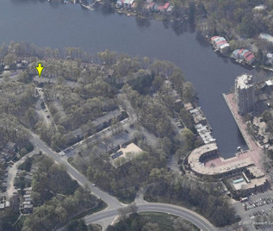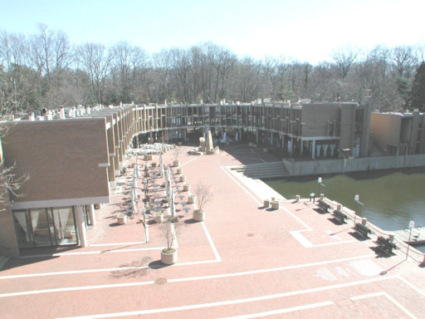

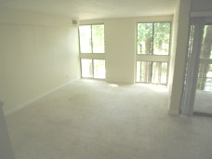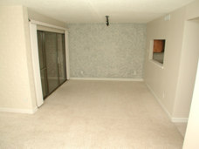

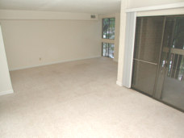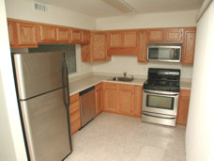

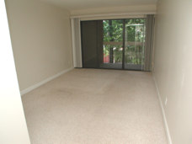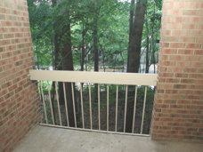

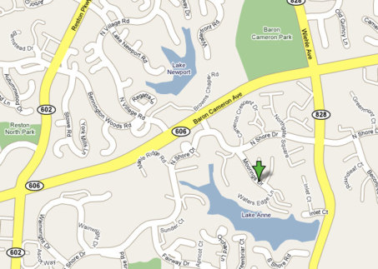

Items that Convey:
■ Stove | ■ Disposer | ◻ Ceiling Fan(s) | ◻ Alarm System
◻ Cooktop | ◻ Freezer | ■ Washer | ◻ Intercom
◻ Wall Oven(s) | ◻ Window Fan(s) | ■ Dryer | ◻ Storage Shed
■ Refrigerator(s) #1 | ◻ Window A/C Unit(s) | ◻ Furnace Humidifier | ◻ Garage Opener(s)
◻ w/ ice maker | ◻ Pool, Equip. & Cover | □ Electronic Air Filter | ◻ w/remote (s)
■ Dishwasher | ◻ Hot Tub, Equip. & Cover | ◻ Central Vacuum | ◻ Playground Equipment
■ Built-in Microwave | ◻ Satellite Dish | ◻ Water Treatment Sys | ◻ Wood Stove
◻ Trash Compactor | ◻ Attic Fan(s) | ■ Exhaust Fan(s) | ◻ Fireplace
◻ Sump Pump | ■ Window Treatments*

* - All items and property Sold As-Is.

Water, Sewage, Heating, and Central Air Conditioning:
Water Supply: | Public | Hot Water: | Gas
Sewage Disposal: | Public | Air Conditioning: | Electric
Heating: | Gas | Stove/Range: | Gas

* - Gas, Heat, Water and basic Cable TV included in Condo Fee.

All information presented in this brochure is believed to be accurate,
but is subject to errors and omissions and should not be relied upon without verification.

