Welcome To
42287 Onyx Terrace
aldie, VA 20105

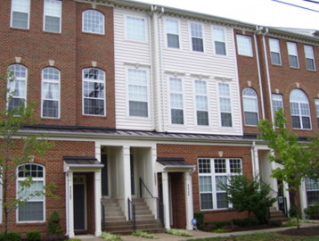
TH/Condo Sqft. | 2180
Bedrooms | 3
Full/Half Baths | 2 / 1
Living Room | 16’ x 13’
Dining Room | 14’ x 11’
Kitchen | 15’ x 10’
Family Room | 13’ x 12”
Master Bedroom | 16’ x 16’
Bedroom #2 | 11’ x 10’
Bedroom #3 | 10’ x 10’

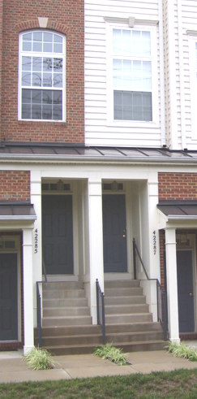

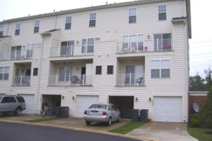

Presented By:


John Thompson

Samson Realty, LLC

14526 Lee Road, Suite 100
Chantilly, VA 20151

Cell: 703.606.0475 Fax: 703.896.5037
E-mail: John@SamsonRealtor.com

Virtual Tour: www.samsonrealtor.com

Noteworthy Features

Amber Spring is an enclave of 170 Townhome-style Condominiums located in Stone Ridge. The Stone Ridge community offers a Recreation Center, outdoor pool, fitness center, tennis, walking/jogging trails and much more. This natural light-filled 2004 built Garage Townhome is in like new condition. Just under 2000 sqft. and numerous high-quality builder options and upgrades add considerable value compared to other units.

- 3 Bedroom, 2 Full baths and 1 Half bath
- Hardwood on main level … Kitchen, Family Room and Dining Room
- Professional decorator paint throughout
- 2-Level Living Dining combination with Oak Railing
- 3-Sided Gas Fireplace separates Kitchen, Family and Dining
- Granite counter-tops and stone backsplash in Kitchen, Oak Cabinets
- Upgraded light fixtures and top-dollar ceiling fans
- Custom Plantation shutters throughout
- Master Suite with vaulted ceiling, plant shelf, huge walk-in closets
- Master Bath with ceramic tile, separate shower, whirlpool soaking tub, double vanity
- 6-Panel doors and brass hardware throughout
- Garage with remote automatic door opener

- Enjoy Stone Ridge Association membership benefits … pool, exercise room, tennis, paths, etc.

- Highly sought, Pinebrook ES, Mercer MS and Freedom HS School Pyramid

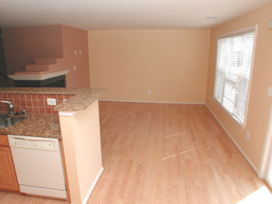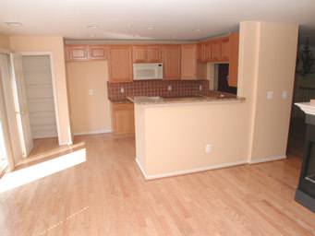

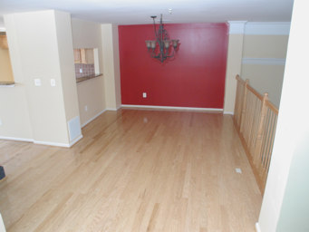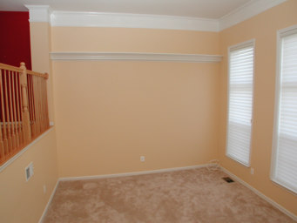

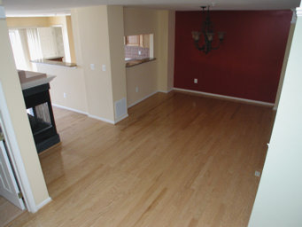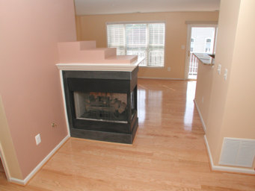

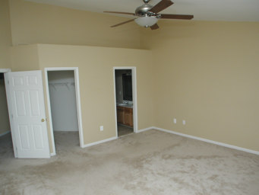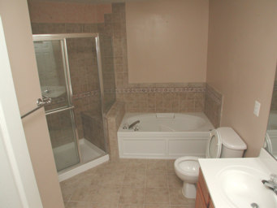

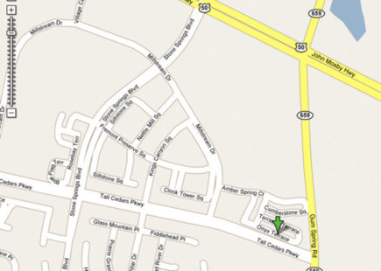

Items that Convey:
◻ Stove | ■ Disposer | ■ Ceiling Fan(s) | ◻ Alarm System
◻ Cooktop | ◻ Freezer | ◻ Washer | ◻ Intercom
◻ Wall Oven(s) | ◻ Window Fan(s) | ◻ Dryer | ◻ Storage Shed
◻ Refrigerator(s) #1 | ◻ Window A/C Unit(s) | ◻ Furnace Humidifier | ■ Garage Opener(s)
◻ w/ ice maker | ◻ Pool, Equip. & Cover | □ Electronic Air Filter | ■ w/remote
■ Dishwasher | ◻ Hot Tub, Equip. & Cover | ◻ Central Vacuum | ◻ Playground Equipment
■ Built-in Microwave | ◻ Satellite Dish | ◻ Water Treatment Sys | ◻ Wood Stove
◻ Trash Compactor | ◻ Attic Fan(s) | ■ Exhaust Fan(s) | ■ Fireplace
◻ Sump Pump | ■ Window Treatments

* - All items, fixtures and property Sold As-Is.

Water, Sewage, Heating, and Central Air Conditioning:
Water Supply: | Public | Hot Water: | Gas
Sewage Disposal: | Public | Air Conditioning: | Electric
Heating: | Gas | Stove/Range: | Gas

All information presented in this brochure is believed to be accurate,
but is subject to errors and omissions and should not be relied upon without verification.

